1. Tools used
   1. Jupyter Notebook
   2. Anaconda with R kernel
   3. Excel
2. Placed dataset files in same folder as that of Jupyter notebook folder
3. Loaded required libraries to use ARIMA model.
4. Visualized data and found that there’s around three years initial data which is not going to contribute in prediction of volume sell.

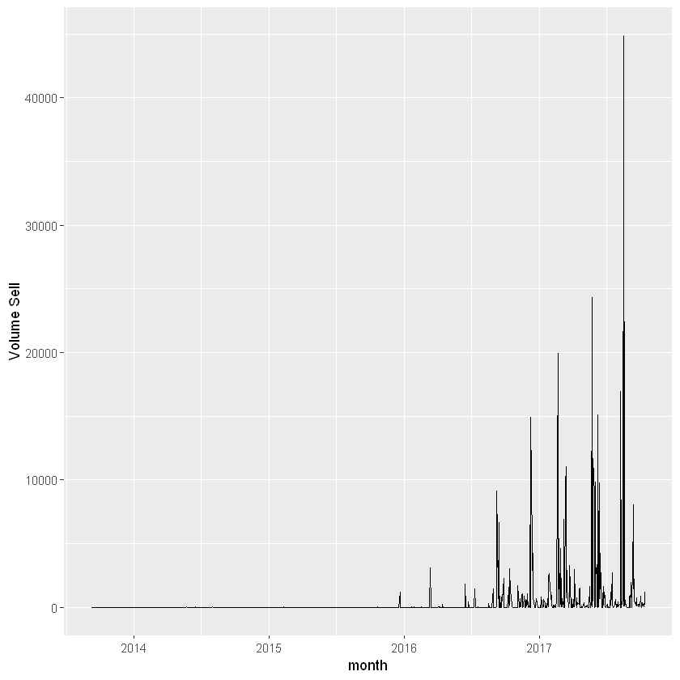

1. Trimmed data which is not required.

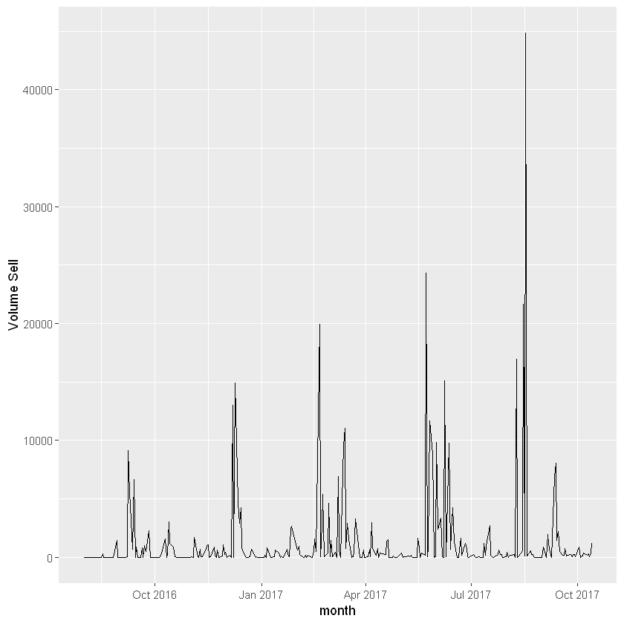

1. Augmented Dickey-Fuller Test to check if Timeseries is stationary - The Augmented Dickey Fuller Test (ADF) is unit root test for stationarity.
2. Convert timestamp to time series and Build ARIM model using auto.arima method.
3. Forecast next 300 days prediction (Test data of 298 and void gap of two days in-between train and test data)
4. Save forecasted values to csv file for further processing.